1. **Dynamic One Dimensional Array.**

#include <stdio.h>

typedef int* int_ptr;

int_ptr init(int size){

int_ptr a;

a = (int_ptr) malloc(sizeof(int)*size);

return a;

}

void display(int *a, int size){

int i;

for(i = 0; i < size; i ++){

printf("%d ",*(a + i));

}

}

void enter_value(int *a, int size){

int i = 0;

for(i = 0 ; i < size; i ++){

printf("Enter element %d: ", i + 1);

scanf("%d", (a + i));

}

}

void main(){

int_ptr b;

int size;

printf("Enter total number of element you want in your array: ");

scanf("%d",&size);

b = init(size);

enter_value(b,size);

display(b, size);

}

**Output:**

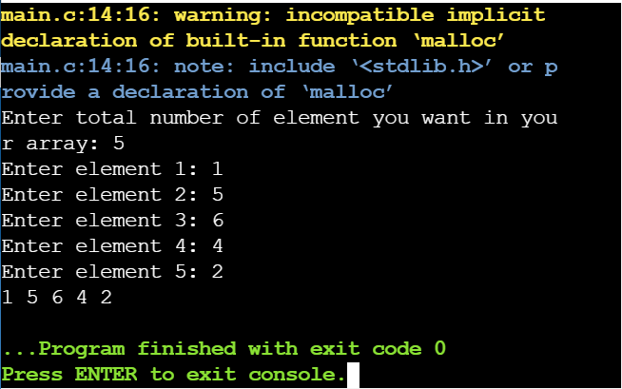

1. **Program to add Dynamic Two Dimensional array in C.**

#include <stdio.h>

#include <stdlib.h>

void display(int**,int, int);

void read(int**,int,int);

void sum(int**,int**,int, int);

int main(){

int row,column, i,j;

int **a,**b,**c;

printf("Enter total number of row and columns: ");

scanf("%d%d",&row,&column);

a = (int**)malloc(sizeof(int*) * row);

b = (int**)malloc(sizeof(int*) * row);

c = (int**)malloc(sizeof(int*) * row);

for(i = 0; i < row; i ++){

*(a + i) = (int*) malloc(sizeof(int)*column);

*(b + i) = (int*) malloc(sizeof(int)*column);

*(c + i) = (int*) malloc(sizeof(int)*column);

}

read(a,row,column);

display(a,row,column);

read(b,row,column);

display(b,row,column);

sum(a,b,row,column);

return 0;

}

void sum(int **a,int **b,int r, int c){

int i,j;

printf("\nSum is: \n");

for(i = 0; i < r; i ++){

for(j = 0; j < c; j ++){

printf("%d ",*(*(a+i) + j) + *(*(b+i) + j));

}

printf("\n");

}}

void display(int **a, int r, int c){

int i,j;

printf("\nMatrix is: \n");

for(i = 0; i < r; i ++){

for(j = 0; j < c; j ++){

printf("%d ",*(*(a + i) + j));

}

printf("\n");

}}

void read(int** a, int r, int c){

int i,j;

printf("Enter elements:\n");

for(i = 0; i < r; i ++){

for(j = 0; j < c; j ++){

scanf("%d",*(a + i) + j);

}}} **Output:**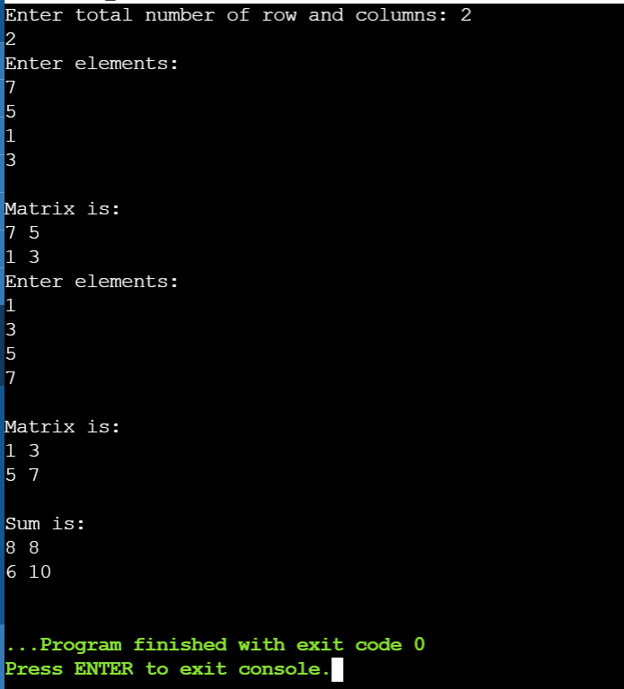

1. **Structure within Structure.**

#include <stdio.h>

#include <string.h>

struct college{

char clz_name[50];

struct Student{

char name[10];

int Class;

} m;

};

int main(){

struct college std;

strcpy(std.clz_name,"Parlance International Academy.");

strcpy(std.m.name,"Abi");

std.m.Class = 10;

printf("Information:\n");

printf("College Name:%s\nStudent Name:%s\nClass:%d",std.clz_name,std.m.name,std.m.Class);

return 0;

}

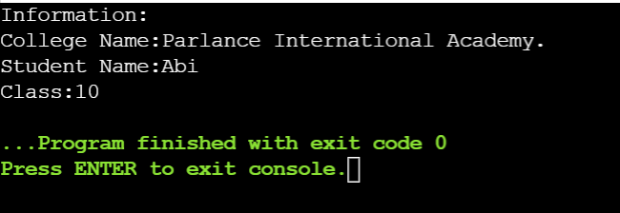**Output:**

1. **Program to Display Names Stored In 2D Array.**

#include <stdio.h>

#include <string.h>

#define ROW 5

#define COLUMN 10

int main(){

char name[ROW][COLUMN]={"TENNIS","FOOTBALL","POLO","VOLLYBALL","CHESS"};

int i,j;

for(i = 0; i < ROW; i ++){

for(j = 0; j < COLUMN; j ++){

printf("%c",name[i][j]);

}

printf("\n");

}

return 0;

}

**Output:**

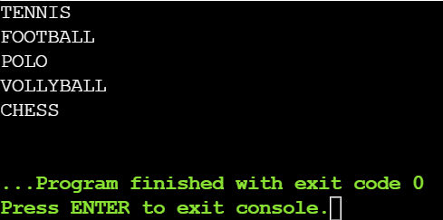

1. **Passing Structure to the function.**

#include <stdio.h>

#include <string.h>

struct Student{

char name[10];

char grade[3];

int roll;

};

typedef struct Student s;

void display(s m){

printf("\nName:%s\nGrade:%s\nRoll:%d",m.name,m.grade,m.roll);

}

int main(){

s a;

strcpy(a.name,"Abi");

strcpy(a.grade, "A+");

a.roll = 2;

printf("Infomation:");

display(a);

return 0;

}

**output:** 